Creativity: Quantity & Quality?

* **Jung, Rex E., et al. "Quantity yields quality when it comes to creativity: a brain and behavioral test of the equal-odds rule." Frontiers in Psychology (2015).**
  + Sehr aktuell
  + Stichwort: divergent thinking
  + Blog-Artikel dazu: http://www.jonahlehrer.com/blog/2015/9/17/quality-quantity-creativity

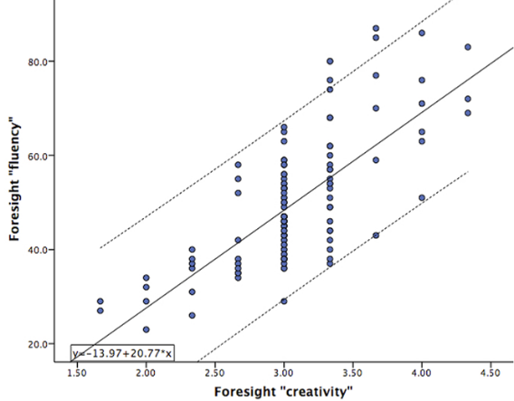

* **Das Theoretische Hauptmodell scheint von Dean Ketih Simonton zu kommen. Er hat die sogenannte „equal odds rule“ konzipiert:** the relationship between the number of hits (i.e., creative successes) and the total number of works produced in a given time period is positive, linear, stochastic, and stable.
  + **Simonton, Dean Keith. "Creative productivity: A predictive and explanatory model of career trajectories and landmarks." *Psychological Review* 104.1 (1997): 66.**
  + **=> http://www.infocenters.co.il/lesley/multimedia/14629.pdf**
* **Brainstorming:** Paulus, Paul B., Nicholas W. Kohn, and Lauren E. Arditti. "Effects of quantity and quality instructions on brainstorming." *The Journal of Creative Behavior* 45.1 (2011): 38-46. <https://www.researchgate.net/profile/Nicholas_Kohn2/publication/260745018_Effects_of_Quantity_and_Quality_Instructions_on_Brainstorming/links/56a3d30608aef91c8c12ea35.pdf> Hier werden in der Introduction viele Studien die sich mit der Frage im Kontext von Brainstorming beschäftigen.
* Zagona, S. V., Willis, J. E., & MacKinnon, W. J. (1966). Group effectiveness in creative problem-solving tasks: An examination of relevant variables. *The Journal of psychology*, *62*(1), 111-137.
* Quality and quantity of accomplishments as measures of creativity. Skager, Rodney W.; Schultz, Charles B.; Klein, Stephen P. Journal of Educational Psychology, Vol 56(1), Feb 1965, 31-39. [http://dx.doi.org/10.1037/h0021901](http://psycnet.apa.org/doi/10.1037/h0021901), <http://psycnet.apa.org/journals/edu/56/1/31/>
* Rietzschel, Eric F., Bernard A. Nijstad, and Wolfgang Stroebe. "Relative accessibility of domain knowledge and creativity: The effects of knowledge activation on the quantity and originality of generated ideas." *Journal of Experimental Social Psychology* 43.6 (2007): 933-946. <http://www.sciencedirect.com/science/article/pii/S0022103106001612>
* Effects of "brainstorming" instructions on creative problem solving by trained and untrained subjects. Parnes, Sidney J.; Meadow, Arnold. Journal of Educational Psychology, Vol 50(4), Aug 1959, 171-176. <http://dx.doi.org/10.1037/h0047223>, <http://psycnet.apa.org/journals/edu/50/4/171/>
* Osborn, „If the quantity goal is critical as suggested by Osborn”: Applied Imagination, Principles and Procedures of Creative Thinking (1953) by Alex F. Osborn
* “Thus a combination of quantity and quality instructions might lead to the greatest number of high quality ideas.” LITCHFIELD, R. C. (2009). Brainstorming rules as assigned goals: Does brainstorming really improve idea quantity? Motivation and Emotion, 33(1), 25-31.